Cinder

provides an infrastructure for managing volumes in OpenStack. It was originally a Nova component called nova-volume, but has become an independent project since the Folsom release.

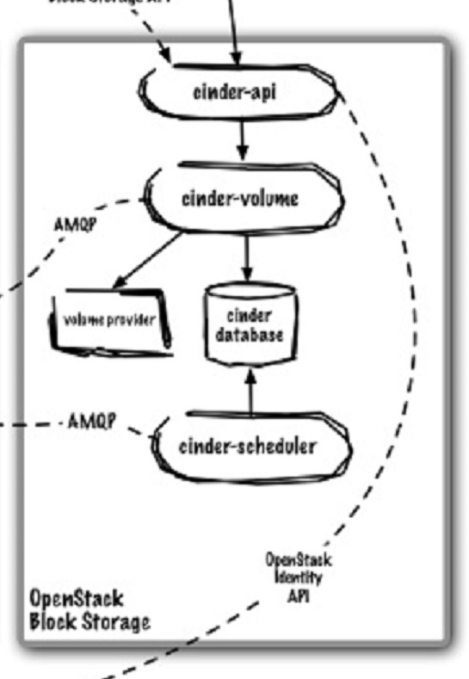 Horizon Python / CLI API

Nova Queue

Nova Queue

Identity (Keystone)

**cinder-api** – api interface

**cinder-volume** – Runs on the storage node and manages the storage space. The volume service can run on multiple nodes, each constituting part of the block storage "pool"; the scheduler service will distribute requests across all nodes that are running the volume service.

**volume provider** – ask about this in class?

**cinder DB** – sql DB for data storage

**cinder scheduler** – Assigns tasks in the queue and determines the volume server to which provisioning requests are sent.